Risk And Audit Module: An architectural Overview

**2012**

Vishwas Babu A J

Conflux Technologies

1/27/2012

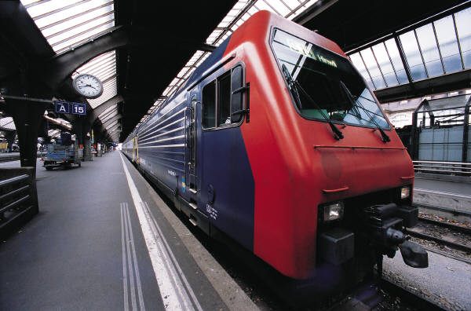

Contents

Approvals 2

Revision History 3

1 Introduction 4

1.1 Purpose 4

1.2 Document Overview 4

1.3 References 4

1.3.1 Business Requirements 4

1.4 Acronyms & Abbreviations 4

2 High Level Overview 4

2.1 Core Audit Module 4

2.2 Data Integration Utility 4

3 Architecture Design 5

3.1 Presentation Tier 6

3.2 Business Tier 6

3.3 Data Access Tier 7

3.4 Cross-cutting concerns 7

# Approvals

|  |  |  |  |
| --- | --- | --- | --- |
| **Role** | **Group / Dept** | **Name** | **Extension** |
| Product Delivery Manager |  | Vishwas Babu A.J |  |
| Sign-off: | |  | |

# Revision History

|  |  |  |  |
| --- | --- | --- | --- |
| Rev.No | Revision History | Change Description | Change Author |
| 1.0.0 | 1/25/2012 | Initial draft | Vishwas Babu A J |
| 1.1.0 | 1/27/2012 | Updates to proposed architecture (Presentation Tier in JSF in-Lieu of Spring MVC) | Vishwas Babu A J |

# Introduction

## Purpose

This document describes the proposed Risk and Audit Module. The primary audience includes architects and developers of the Portal

## Document Overview

This document is intended to provide a high-level Architectural design for the proposed portal. The audience can expect to find information about constraints, patterns and structures used within all tiers of the application.

## References

This section lists the number, title, revision, and date of all documents referenced in this document.

### Business Requirements

Chaitanya-Mockups_v1.3.pdf

## Acronyms & Abbreviations

|  |  |
| --- | --- |
| Term | Definition |
| AOP | Aspect Oriented Programming |
| DAL | Data Abstraction Layer |
| DTO | Data Transfer Object |
| JPA | Java Persistence API |
| JSF | Java Server Faces |

# High Level Overview

The proposed module, adds Audit and Risk Management functionality to an existing MIS (Delfix). The module consists of the following components

## Core Audit Module

An application built using a JEE technology stack and using MySQL as its backend. For additional details refer here

## Data Integration Utility

This utility connects to an existing MIS and pulls relevant data including details of Loan Officers, Branch Hierarchies, customers and their loan accounts to the MySQL database used by the Core Audit Module.

The tool also monitors changes (disbursal of loans, addition of new clients etc) to the target MIS database (initially Delfix) and updates the same into our applications MySQL database.

The Utility is built using [Kettle](http://kettle.pentaho.com/). The rationale behind using Kettle in lieu of native SQL procedures or functions and Triggers is that we want the utility to be independent of the target database.

Using Kettle provides us with the flexibility of changing the target database (for ex, to a Mifos database) in the future and reusing the same tool with Minor modifications.

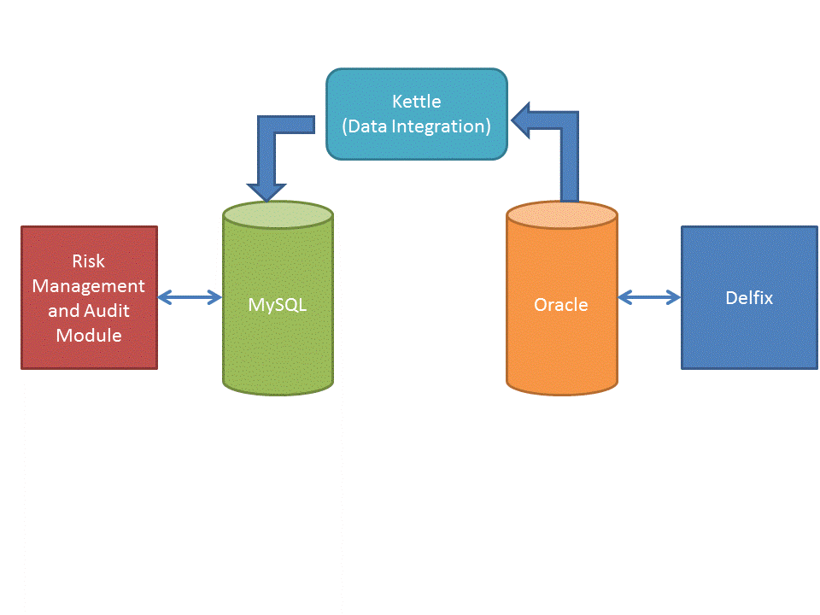

High Level Overview

# Architecture Design

The application shall be built using a standard n-Tier architecture, where each tier has a distinct responsibility and for achieving the same, services exposed by the layers below it are consumed.

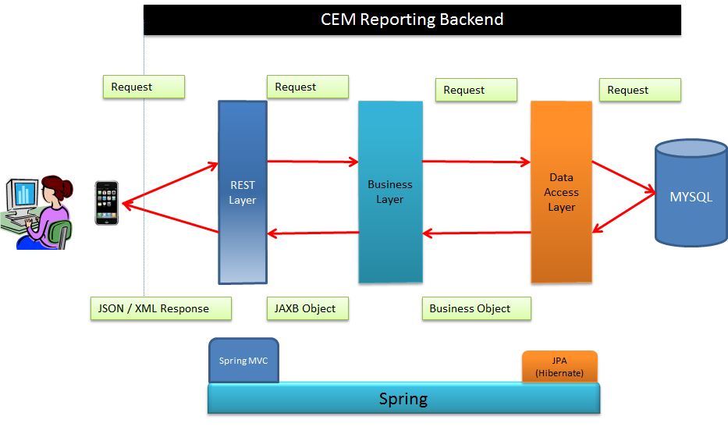

Risk Management and Audit Module

JSF

Presentation Tier

## Presentation Tier

The presentation tier shall be built around the JSF framework ([Prime Faces](http://primefaces.org/)) coupled with the popular JavaScript frameworks [JQuery](http://jquery.com/) and [JQueryUI](http://jqueryui.com/).

The purpose of using standard web technologies (vis-à-vis Flex etc.) is to ensure compatibility on a majority of devices (including the iPad which does not support Flash Content) and popular browsers like the latest versions of IE, Chrome, Firefox and Opera.

Interactive charting requirements shall be provided using the [Highcharts](http://www.highcharts.com/) . For more complex Reporting requirements, an integrated [Pentaho](http://jasperforge.org/projects/jasperreports) Reporting engine shall be used which allows exporting data in a variety of document formats (including HTML, PDF, and CSV)

Since the UI is decoupled from the application (built using RESTful architecture), the architecture is flexible and if the need arises, UI can be built for other platforms like iPhone and Android devices without any changes to the Reporting backend.

## Business Tier

The business tier is responsible for handling business logic, calculations etc. It is also responsible for moving data between the Data Access and the REST Layers.

To enforce best practices and speed up development, the business tier shall be built using the [spring](http://www.springsource.org/) framework.

In addition to accessing the Data access layer, this layer shall have modules for periodically carrying out various calculations like risk rating of Centers etc (using the [Quartz framework](http://www.quartz-scheduler.org/))

## Data Access Tier

The data access tier is responsible for fetching /storing data to a relational Database

This layer shall be agnostic to the actual relational database used (MySQL). The layer shall be coded with strict adherence to [JPA](http://www.oracle.com/technetwork/articles/javaee/jpa-137156.html) spec. [Hibernate](http://www.hibernate.org/) shall be used as the JPA provider; however strict adherence to the spec ensures that we can change the provider if required.

## Cross-cutting concerns

The application shall use industry standard frameworks like [log4j](http://logging.apache.org/log4j/1.2/) for logging etc.

Further, cross cutting concerns like logging and Exception handling shall be handled using aspects (spring AOP) thereby ensuring no code duplication.

The application shall be secured using [Spring Security Framework](http://static.springsource.org/spring-security/site/).